New York University
Introduction to Accounting and Finance (LAW-LW.12337.001; ACCT-GB 3308.20)
MW 9:15-10:45 AM

Professor April Klein
E-Mail: ak5@stern.nyu.edu
Office: K-MEC 10-74 (corner of Greene and West 4th Street)
Office Hours: TBA

1. Required Textbook

There is a customized textbook incorporating chapters from Libby, Libby, and Hodge (LLH) Financial Accounting, 11th edition (2023, McGraw-Hill) and Ross, Westerfield, and Jordan (RWJ) Essentials of Corporate Finance, 11th edition (2023, McGraw-Hill).

Please note: McGraw-Hill puts the customized textbook together by placing the accounting text first and the finance book second. In the syllabus, I will use the chapters as listed in the book itself (that is, please ignore the table of contents); I will also put the title of the chapter next to its number.

You can buy the book or the ebook through the NYU Bookstore.
For the ebook, here is the relevant information:
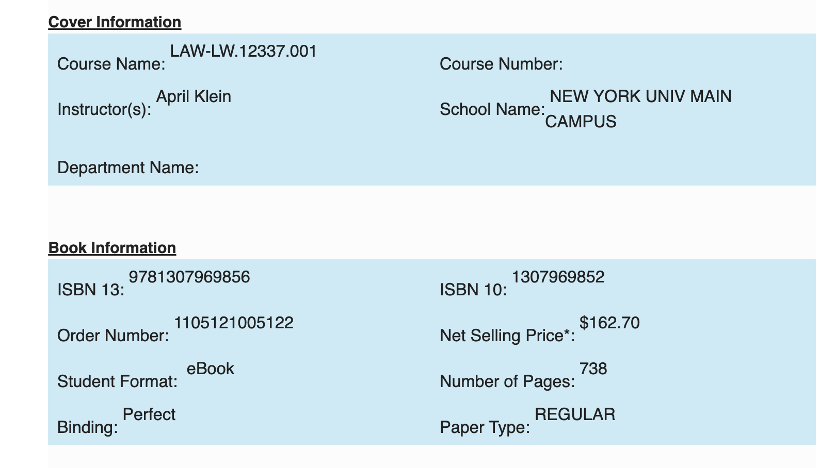

If you prefer a print copy, here is the relevant information:
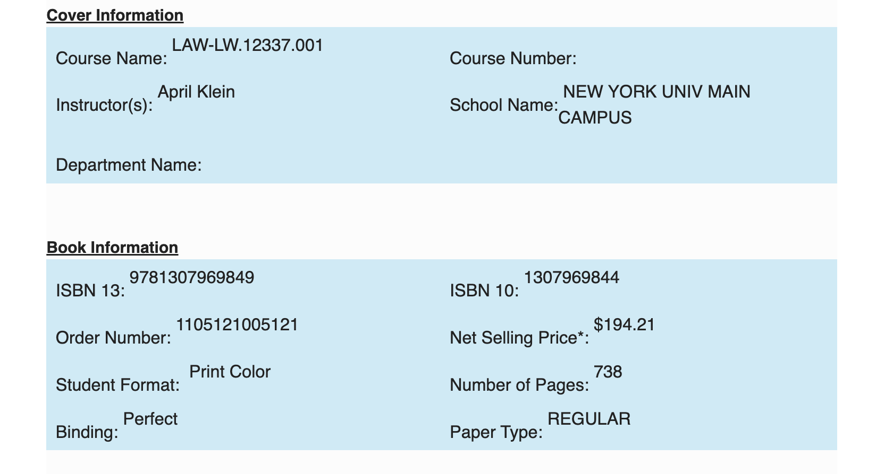 I view the textbook as an important tool, but also as background reading. We will be covering many things in class that are not in the book. Similarly, there will be things in the book that we will not cover in class.

I will place all of the power point slides and problem sets on line under Brightspace. Please have the relevant slides and problem sets ready for each and every class.

We will be using several 10-K Filing as well. The most prominent one is the latest Apple 10-K filing. I will place the full 10-K on Brightspace under Content.

2. Preparation for Class Sessions
Prior to each class, you should read the assigned chapters. In addition, there will a few “preparation problems” assigned prior to each class. These problems cover some of the basic concepts in the chapter. These concepts will be reviewed in class, but at a quicker pace, so I strongly recommend that you do them. They are purely optional and will not count towards your final grade.
In addition, to make the class a bit more interesting (but really, what is more interesting than accounting and finance?), I have put some readings and videos on the syllabus for you to read PRIOR to class. Reading or viewing them will improve on the class discussion.

The syllabus also contains homework problems. I recommend that you do these immediately after we finish each chapter. The best way to learn accounting is to practice it, and these homework problems will help you solidify (and edify) your knowledge of the subject matter. I will post the answers to all of the preparation and homework problems in a folder in Brightspace.

Keep up with the coursework! Accounting and finance are not conducive to cramming for the exam because new material builds on prior concepts.

The class will revolve around the power point slides that will be uploaded on Brightspace. We will be solving problems so you will need a calculator. As you will be given the formulae and present value sheets for doing many of problems, you do not need to buy a financial calculator, unless you would like to do so. I leave the choice to you.

3. Grading

A. Final Exam (compulsory): 90%-100%

The final exam is open book/open note. You can use the textbook, all class notes (yours and mine), the 10-K reports that we use in class and a calculator. You cannot use a cellphone, computer, or any other similar type of device. You also cannot confer with anyone during the test (don’t laugh, I once had a student try to bring in a relative for a live exam). All students must take the final exam.

B. Write-up on Fraud (optional 10%)

On Brightspace, I will post an assignment about famous frauds. You should select 2 of the frauds from the list, and CAREFULLY answer the questions. The assignment will be due on the last day of the class. Please keep to the suggested style (font, spacing) and to the requested maximum number of pages.

There is a P/F option for this class.

4. Course Policies

a. Attendance
I do not take attendance. However, if you miss a class, it is your responsibility to make it up.

b. Late Arrivals
I would appreciate it if you could arrive to class on time.
Note: LLH is Libby, Libby and Hodge
RWJ is Ross Westerfield and Jordan
Class Schedule (approximation)

INTRODUCTION

January 17: Introduction to Class

Brief Introduction to what Financial Accounting and Corporate Finance is. Also, we will go over the requirements for the class.

Read: LLH Chapter 1: Financial Statements and Business Decisions

(Note: this is just an introduction to the class, if you don’t get everything from this chapter, don’t worry. If this chapter “freaks you out” then skip it)

January 22: Regulatory Environment for Financial Reporting

In class (on Brightspace): Auditor’s Opinion of Apple

See: https://www.sec.gov/answers/form10q.htm
https://corporatefinanceinstitute.com/resources/economics/sarbanes-oxley-act/
https://www.sec.gov/files/form10-k.pdf

New rules for 404(b): audit of a firm’s internal controls: https://www.sec.gov/corpfin/secg-accelerated-filer-and-large-accelerated-filer-definitions

ACCOUNTING FUNDAMENTALS

January 24 & 29 & 31: What is a Balance Sheet? How does it fit in with the Statement of Cash Flows? Introduction to Analyzing Transactions

Read: LLH Chapter 2: Investing and Financing Decisions and the Accounting System; Chapter 1, pp. 15-16 (Statement of Cash Flows)

In class (on Brightspace): Balance Sheet Redux

Preparation Problems: Prior to 1/24: M2-4, M2-5; Prior to 1/31: M2-6, M2-13

Homework Problems:
- Fundamentals of Accounting
E2-3, E2-4, E2-6, E2-11 & E2-18 (working backwards), E2-19, P2-5 (comprehensive problem)
- Reading and Interpreting Financial Statements
CP2-2 (Walmart), CP2-3 (Walmart & Target), CP2-6

February 5 & 7 & 12: What is an Income Statement? How does it fit in with the Balance Sheet and the Statement of Cash Flows? Introduction and Analyzing Transactions

Read: LLH Chapter 3: Operating Decisions and the Accounting System
LLH Chapter 1: pp. 10-11

In addition, please read and view
- the materials on Kraft Heinz (they are in reverse chronological order)
https://www.wsj.com/articles/kraft-heinz-to-pay-62-million-to-settle-sec-accounting-probe-11630676482 September 2021

https://www.youtube.com/watch?v=GqaPby5v078&ab_channel=WallStreetMillennial KraftHeinz fraud

https://www.wsj.com/articles/kraft-heinz-kellogg-say-pandemic-boosted-demand-for-packaged-food-11596114768 2020 Q2

https://www.wsj.com/articles/kraft-heinz-discloses-sec-probe-misses-earnings-forecasts-11550789493 2018 Q4

https://www.youtube.com/watch?v=0WTHsitgLqQ (CNBC cost cutting: in class)

https://www.youtube.com/watch?v=IEP7RUKuI0U (Buffett)

- the reading on MiMedX (under Brightspace: Income Statement)

In class (under Brightspace): Income Statement Redux

Preparation Problems: M3-1, E3-1(getting used to the language)
Homework Problems
- Fundamentals of Accounting
E3-2, E3-3, E3-4, E3-18 (working backwards), P3-4 & P3-5 (comprehensive problem), COMP3-1 (another comprehensive problem)
- Reading and Interpreting Financial Statements
CP3-2 (Walmart), CP3-3 (Walmart & Target)

February 14: What are Adjusting Entries? Contra Accounts?

Review LLH Chapters 2 & 3; Read Chapter 4: Adjustments, Financial Statements, and the Closing Process

Homework Problems
- Fundamentals of Accounting
E4-8, E4-10, E4-15 (working backwards) – for more practice: P4-2 & P4-4
- Reading and Interpreting Financial Statements
CP4-2 (Walmart), CP4-3 (Walmart & Target)

***February 20***: Problem Session & Management Forecasting (what could go wrong?)

***Reminder: There is no class on Monday February 19 due to it being a school holiday. Instead, Tuesday February 20 is the designated “legislative Monday”

In class (on Brightspace): CP4-9 and Queen McPea

Homework Problem: CP4-2 (a summary problem similar to Queen McPea)

FINANCE & FINANCIAL ACCOUNTING

February 22 & 27 & March 1: What is the Time Value of Money? How do we calculate and apply Present Values? What are Bonds? How do we account for them?

Bring in PV Tables (in Brightspace) for all three classes

Read: RWJ Chapter 4: Introduction to Valuation: The Time Value of Money (ignore the stuff on Using a Financial Calculator. We primarily are going to be using PV Tables instead.)
RWJ Chapter 5: Discounted Cash Flow Valuation (again ignore the stuff on Using a Financial Calculator)
LLH Chapter 10: Reporting and Interpreting Bond Securities (to p. 546)

In class (on Brightspace): NPV of a NYU Law Degree, AP8-7

Preparation Problems:
Prior to 2/22: RWJ: Chapter 4 - Critical Thinking and Concepts Review 4.2, 4.3, 4.8; and RWJ: Chapter 5 - Critical Thinking and Concepts Review 5.1, 5.2, 5.5;

Prior to 3/1: LLH M10-1, M10-2, E10-1

Homework Problems
RWJ Chapter 4 – Questions & Problems 2, 3, 10
RWJ Chapter 5 – Questions & Problems 1, 3, 6, 10, 12, 17, 18, 35
LLH Chapter 10 – E10-3, E10-7, E10-24, P10-1 (note a different specification for the Debt-to-equity ratio), P10-6, CP10-2 (Walmart) CP10-3 (Walmart & Target);

March 6 & 8: Stockholders’ Equity, ROE, and Leverage

Read: LLH Chapter 11 Reporting and Interpreting Stockholders’ Equity
RWJ Chapter 3 Working with Financial Statements pp. 67-70

In Class (on Brightspace): RWJ Ch.3: Questions and Problems 7 & 8; Lehman Brothers (see below)

Preparation Problems: LLH M11-1, M11-3, M11-7, E11-4

Homework Problems
LLH: M11-4, E11-2, E11-6, E11-8, E11-16, E11-20, P11-1, CP11-2 (Walmart), CP11-3(Walmart & Target); RWJ Ch. 3 Questions & Problems 17, 18

For March 8: Please read: The Lehman Brothers Case – When Leverage is both a Blessing and a Curse (on Brightspace)
Please watch https://www.youtube.com/watch?v=Dacem0p5Ilc&ab_channel=StartupDivision

March 20: Efficient Capital Markets

Read: RWJ Chapter 10: Some Lessons from Capital Market History pp. 342-346 [section 10.6 in the textbook]
Review the Supreme Court case: Basic Inc. v. Levinson, (1988)
Review the Supreme Court case: Halliburton v. Erica P. John Fund, (2014)
Review the Supreme Court case: Goldman Sachs Group v. Arkansas Teacher Retirement System, (2020)

March 22 & 27 & 29: Statistics, Risk-Return Trade-off and Diversification

Read: RWJ Chapter 10: Some Lessons from Capital Market History pp. 315-341
RWJ Chapter 11 Risk and Return

In Class (on Brightspace): Risk-Expected Returns In Class Problems

Preparation Problems: RWJ Ch.10: Questions and Problems 1, 2; Ch. 11: Questions & Problems 1, 2

Homework Problems
RWJ Chapter 10: Questions & Problems 7, 9, 14, 17, 21
RWJ Chapter 11: Questions & Problems 3, 6, 7, 11, 13, 18, 23, 24

April 3: Options Markets and Equity Compensation

There are a lot of videos explaining options. Here is a simple and viewer friendly one:
https://www.youtube.com/watch?v=S0J70FjCp3c

It is only a few minutes long and you might want to view it before class.

An article you might find interesting is: https://blog.wealthfront.com/stock-options-versus-rsu/ It is about the difference between stock options and RSUs and talks about the tax differences. Its setting is private firms thinking of going public, so as attorneys, you might find it useful.

DIGGING DEEPER: RECEIVABLES AND MARKETABLE SECURITIES

April 5, 10 & 12: What are Receivables? How do we account for Bad Debts? Loan Losses? What are the three types of Investments a firm can hold? How do we account for them? How do we account for M&A transactions?

For April 5: Read LLH Chapter 6: Reporting and Interpreting Sales Revenue, Receivables, and Cash pp. 297-307 (We also will go into this from a bank’s perspective)

In class: E6-8, , M6-4, E6-20
Preparation Problems: M6-4 (If you understand this, you got the idea behind the accounting for bad debts), E 6-15

Homework Problems
1) Fundamentals of Accounting
E6-13, E6-19, E6-24, P6-2
2) Reading and Interpreting Financial Statements
CP6-2 (Walmart), CP6-3 (Walmart & Target)
- Bank Example (see Brightspace)

For April 10 & 12: Read: LLH Appendix A: Reporting and Interpreting Investments in Other Corporations

In class: Silicon Valley Bank; PA-4
Please watch: https://www.youtube.com/watch?v=QACGoKb48_0

Preparation Problems: LLH MA-1

Homework Problems:
1) Fundamentals of Accounting
LLH EA-1, EA-2, EA-3, EA-4, EA-5, EA-6 (This is a tough one), PA-2, PA-5
2) Reading and Interpreting Financial Statements
LLH CPA-2 (Walmart), CPA-3 (Walmart & Target)

THE STATEMENT OF CASH FLOWS

April 17 & 19 What is the Statement of Cash Flows? How can we use it spot the Red Flags of a company?

Read: LLH Chapter 12 :Statement of Cash Flows; Supplement B (pp. 654-655) (Optional: Supplement A)

In class: E12-8, E12-10, E12-11

Preparation Problems: LLH M12-5, M12-6, M12-7

Homework Problems:
- Fundamentals of Accounting
E12-1, E12-6, E12-12, E12-16,
- Reading and Interpreting Financial Statements
E12-9, CP12-2 (Walmart)

In addition, please read https://www.cnbc.com/2020/07/01/luckin-coffee-says-probe-into-sales-fraud-is-substantially-complete.html

April 24: Review and Q&A for Final Exam

