PRINCIPLES OF FINANCIAL ACCOUNTING – UB1
PROFESSOR ALEX DONTOH
PRINCIPLES OF FINANCIAL ACCOUNTING
Summer 2024

Instructor  Alex Dontoh  adontoh@stern.nyu.edu  Office Hrs. M/W 12:30-1:30 pm | Teaching Fellow  Office Hours: M/W 5-6:30 pm

Course Description
Financial accounting reports are used in valuation and contracting by investors, creditors, managers, and the government. Therefore, a good understanding of these reports is one of the basic building blocks of any business education. The course introduces the development, preparation, analysis, and use of financial reports. The course aims to help students understand the contents of financial reports and the fundamental concepts and assumptions underlying their preparation. It is divided into two parts; Part I is designed to develop your appreciation of fundamental accounting concepts. Part II focuses on earnings quality issues and earnings management activities related to assets, liabilities, and equity. Topics covered include accounts receivables, inventory, long-term assets, intangible assets, bonds, leases, income taxes, and shareholders' equity.

Course Learning Outcomes (CLOs)
The objective of this course is to provide students with:
- An understanding of the core concepts of financial accounting, including how accountants analyze and record the effects of individual transactions and the concepts essential to understanding financial reports such as assets, liabilities, owners' equity, revenues, expenses, and cash flows.
- An ability to analyze a company's performance from financial statements.
- An ability to summarize and quantify real-life outcomes of business decisions and transactions through financial statements.

Teaching and Learning Methodologies
The most efficient use of class time reinforces what the student already knows about the topic individually from preparing for class. In-the-classroom learning is achieved by i. whole-hearted and focused studying the assigned readings and solving the assigned problems or cases; ii. discussions of the material by the students and instructor during class sections; iii. underscoring important points via short lectures by the instructor. Students need to prepare for every class adequately and actively participate in class discussions for this to work.

The CONNECT Platform
The course textbook includes access to the McGraw-Hill CONNECT platform, an online digital learning and assessment tool. I will administer most class assignments through CONNECT web-based assignment and assessment platform. Please be aware that the current version of CONNECT is linked to the 11th edition of the required textbook (See details in the Course Materials section below); earlier editions are incompatible with the platform. Therefore, should you acquire the text from a source other than the bookstore, please ascertain it is the 11th edition and comes bundled with the access code needed to register for CONNECT. You may purchase the access code separately, but acquiring the option bundled with the 11th edition textbook available at the NYU bookstore is considerably cheaper. See page 4 below for instructions on how to register for Connect.

Preparing for Class – Pre-Class Assignments
We have a considerable amount of material to cover relatively quickly. You are responsible for carefully reading the class schedule provided on pages 8-9 of this syllabus to determine the required reading assignments for each class session. A pre-class assignment based on reading assignments for that class will precede each meeting. I shall administer all pre-class assignments through the Connect platform established for the class. Since pre-class assignments aim to prepare you adequately for each class, the system will allow you multiple attempts to complete assignments and provide immediate feedback upon completion.

Homework Assignments
The homework problems are more challenging than pre-class assignments and are typically due after discussing the relevant chapter. I encourage you to do the homework in small groups of 3-4 people. If you do this, you will find yourself far more engaged and far better prepared for class and learn significantly more. Please understand that doing these exercises and problems is the key to success in the course. Finally, I should point out that I will not accept late homework assignments unless due to documented serious illness or family emergency. However, I will make an exception to this policy for religious observance or civic obligation, but only when you notify me in advance.

Tests and Exams
There will be several quizzes, one midterm, and a final exam. Due to the course material's progressive nature, all exams will be cumulative unless I indicate otherwise.

Class Attendance/Presence:
Class attendance constitutes an essential part of your course grade and is required. Absences may be excused only in documented severe illness, family emergency, religious observance, civic or necessary work obligation. If you anticipate missing a class for religious observance or a civic obligation, you must inform me no later than the first week of class. Recruiting activities and business trips are not acceptable reasons for absence from class. You are responsible for knowing what goes on in class, including modifications to the syllabus, announcements concerning exams, and material not covered in the readings. I will make most course announcements on the NYU LMS Brightspace course platform or by email sent only to your official NYU email addresses. It is your responsibility to check class emails frequently. Also, you must check the course platform regularly and often. My advice to you is to make an effort to attend every class session since class participation will count toward your course grade.

Arriving Late, Leaving Early, Coming & Going
Students are expected to arrive at class on time and stay until the end of the class period. Arriving late or leaving in the middle of the class will impact your course grade. Students may join the class late only if given permission and can do so without disrupting the class. I would appreciate knowing if you will come to class late and if late, to do so as unobtrusively as possible. You are encouraged to participate in class discussions. However, you are not allowed to use smartphones and other electronic devices during class and exams unless permitted to do so.

Academic Integrity
Integrity is critical to the learning process and all we do here at NYU. Therefore, as members of our community, all students agree to abide by the NYU Student Code of Conduct, which includes a commitment to:
- Exercise integrity in all aspects of one's academic work, including, but not limited to, the preparation and completion of exams, papers, and all other course requirements by not engaging in any method or means that provides an unfair advantage.
- You are expected to acknowledge others' work and efforts when submitting written work as one's own. Ideas, data, direct quotations (which should be designated with quotation marks), paraphrasing, creative expression, or any other incorporation of others' work should be fully referenced.
- You are expected to refrain from behaving in ways that knowingly support, assist, or in any way attempt to enable another person to engage in any violation of this Code of Conduct. This includes reporting any observed violations of this Code of Conduct or other School and University policies that are deemed to affect the NYU community adversely.

General Conduct & Behavior
Students are also expected to maintain and abide by professional conduct and behavior standards. Please read NYU's policy regarding in-class behavior & expectations and the NYU Disruptive Behavior Policy at the following site:
(https://www.nyu.edu/about/policies-guidelines-compliance/policies-and-guidelines/university-student-conduct-policy.html).

Moses Center for Student Accessibility
The Moses Center for Students Accessibility at New York University is committed to providing equal educational opportunity and participation for students with disabilities. CSA works with NYU students to determine appropriate and reasonable accommodations that support equal access to a world-class education. Confidentiality is of the utmost importance. Disability-related information is never disclosed without student permission. If you have any questions or would like to have further information about this, please visit the following link:
https://www.nyu.edu/students/communities-and-groups/student-accessibility.html
Contact: mosescsd@nyu.edu

Mental Health Resources:
As a University student, you may experience a range of issues that can interfere with your ability to perform academically or impact your daily functioning, such as heightened stress; anxiety; difficulty concentrating; sleep disturbance; strained relationships; grief and loss; personal struggles. If you have any well-being or mental health concerns, please visit the Counseling Center on the ground floor of the campus center from 9am-5pm Sunday - Thursday, or schedule an appointment to meet with a counselor by calling: 212-628-8100 or emailing: nyuad.healthcenter@nyu.edu. If you require mental health support outside these hours, call NYU's Wellness Exchange hotline at 212-628-5555, which is available 24 hours a day, 7 days a week. You can also utilize the Wellness Exchange mobile chat feature, details of which you can find on the student portal.

Grading Policy
Attendance and Participation 5%  Prep Assignments 10%  Homework Assignments 10% | Midterm Exam 30%  Final Exam 45%

CONNECT REGISTRATION AND LOGIN
- Go to the course Connect website by clicking on the link below (alternatively, you can copy and paste the link into a browser) https://connect.mheducation.com/class/a-dontoh-online-section
- You can also access it from the link provided by NYU LMS. First, the Welcome Screen below left will show. Next, enter your NYU email address (Do not use your Stern or any other email address) and enter BEGIN to bring up the registration screen below.
- Confirm the course and instructor information on the screen's right side, enter your NYU email in the space provided, and click "BEGIN."
3. Enter the requested information. Please use Your NYU email address. Agree to the terms and click CONTINUE.
4. Next, you will be presented with three options:
a. If you already received an access code with your new text OR if you purchased an access card from your bookstore, enter your code in the appropriate field and click "REDEEM."
b. If you don't have a code, click either "BUY IT "to purchase one with a credit card or PayPal.
c. Click "RENT IT" to rent the hard copy version.
d. Not ready to purchase yet? Get started with two weeks free of access to Connect by clicking on "ACCESS NOW" Your work will be saved and available to you and the instructor when you complete the purchase.
5. Once you have completed and submitted the form, you can access the course homepage.
6. At your Connect homepage, you can access Practice Assignment 1 to be completed after you have read chapter 1 of the text. Start by clicking the assignment title displayed.

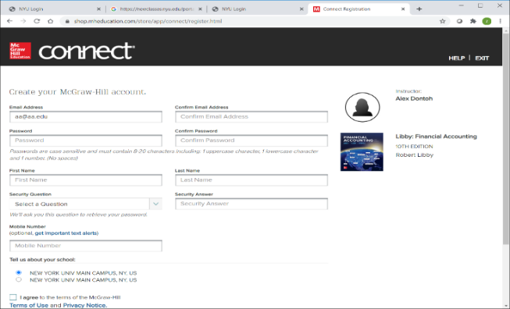
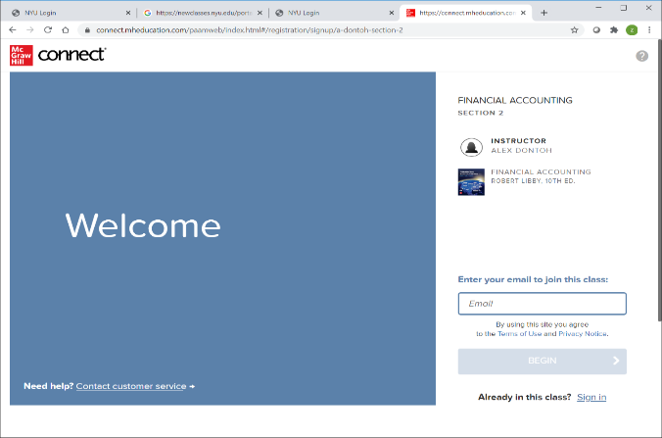

NYU LMS BRIGHTSPACE REGISTRATION AND LOGIN
NYU LMS course platform shall serve as a depository for all class materials and a portal to the Connect platform. To access the course, you will first need to log into NYU LMS using your NYU account here: https://brightspace.nyu.edu/d2l/home and select your class from the tabs at the top of the screen (you can also use the NYU mobile app, tap on the drop-down tab and select NYU LMS (Brightspace), tap on the MY SITES tab and select your class section).

The class will consist of a synchronous session during scheduled class times (see the detailed course schedule on pages 8-9 below) and asynchronous pre-class and post-class sessions. I will post a "Zoom Session" slide to guide our discussion during the "live" Zoom session.

ACCESSING ZOOM
To access Zoom, please follow the instructions here; it is also attached to this message. Please note that activating your NYU Zoom account is necessary by navigating the NYU Zoom web portal @ https://nyu.zoom.us/ and clicking Login at the bottom. Input your NYU NetID and password if prompted. When you're logged in, click the icon at the top right. It should have your nyu.edu email address and say LICENSED. If you already downloaded the Zoom app, please sign out of your existing account and Login at the NYU Zoom site: https://nyu.zoom.us/. If you don't have the desktop app, download it here: https://zoom.us/download. Follows the instruction in the attached from these.

The following is essential; you must sign in to Zoom with SSO (Single Sign-On) using your NYU email address (your NETID@nyu.edu) and password; otherwise, you will not be able to access the class on Zoom. Please DON'T Login with your Stern email address; it won't work! You'll know that you're logged into the Zoom app with your NYU account by clicking the icon at the upper right. You should see your nyu.edu email address (not your Stern email address) if you see your Stern email address, log out and Login in with SSO using your NYU email address (your NETID@nyu.edu). Here is the course Zoom Link: https://nyu.zoom.us/meeting/register/tJwvdeCqrTwpHND_czeEV2vf_hYquyVmb4Ce

Before joining your class meeting, open your Zoom app and check to ensure you are logged in to your NYU Zoom account. Then, go to NYU Classes to join the session by clicking on the Zoom tab in the drop-down menu and join the appropriate online class session. Please see the detailed instructions attached.

PREPARING FOR A ZOOM CLASSROOM

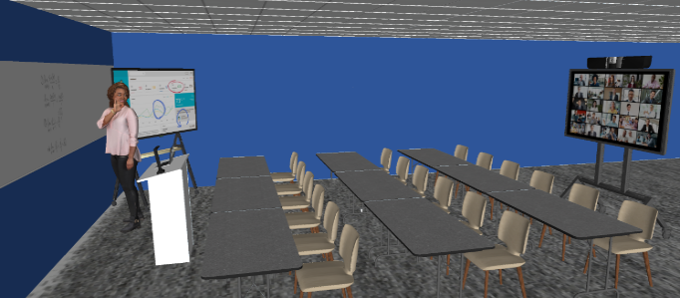
1. GETTING ORGANIZED
- If you can, establish a consistent, quiet, well-lit location for your Zoom classes.

- Add a professional profile photo to your Zoom account for when you're not on camera at nyu.zoom.us

- Connect with classmates for group work by setting up your own Zoom meetings at nyu.zoom.us

- Use Google Apps to collaborate with others on shared documents.

- Pair up with a classmate so there is someone you can reach out to quickly if you get stuck or can't join a class meeting.

2. GETTING READY FOR A ZOOM CLASS

- Use the raised hand icon or chat to ask questions. You may also submit questions before class.

- Dress appropriately.

- Gather everything you will need, to avoid moving around during class.

- Make it a habit to log in to nyu.zoom.us before each class with your NYU email (Do not use your Stern email address to log in) to avoid various problems other ways of logging in can cause.

- Close out distracting tabs/windows that aren't related to class so you can be present. If you are screen sharing, ensure you have closed out anything personal.

- Turn off desktop notifications and mute your phone during the session.

- You are required to turn on your camera and keep it on during class. Let me or the TA know if using a camera presents a problem in advance.

- Check your camera angle and lighting. Make sure your whole face is visible and well-lit.

- Use a virtual background if there is any chance of distractions behind you, but don't distract others by changing it during class.

- Log in early, so you are already set up when the class is scheduled to begin.
3. DURING CLASS

- Mute your microphone unless you are called upon to speak.

- Keep your camera on at all times, but remember that everyone can see you!

- Try to avoid interrupting others. If you have a question or comment, use the raise hand feature or post it in chat.

- Say your name before speaking, so people know whose voice they are hearing.

- Look at the camera to signal that you are paying attention.

- Refer to people by name out loud and in chat to keep follow-up questions in context.

COURSE MATERIALS
Textbook
The textbook for the course is Financial Accounting 11th Ed., (Custom Edition for New York University – Digital and Print versions), by Robert Libby, Patricia Libby, and Frank Hodge, McGraw Hill, New York, 2019 ISBN # 978-126-408216-2. All assigned readings and pre-class assignments are from this text.
e-book.
An electronic version of the textbook is included in Connect Registration.

Coursepack
A course pack containing templates for all class slides, illustrative cases, and extra practice problems and solutions will be provided. You are expected to bring relevant sections of the course pack to class. Copies will be posted on NYU LMS for download at no cost to you.
Practice Problem Set
The problem sets contain numerous problems and solutions, including end-of-chapter problems from the textbook. There are three practice problem sets; Problem Set 1 contains the Accounting Cycle and Cash Flow Statements. Set 2 contains problems and solutions on Accounts Receivable, Inventories, and Long-Lived Tangible and Intangible Assets. Problem Set 3 contains problems and solutions on present value concepts, bond valuation, bond interest expense calculations, and stockholders' equity. Sections of the Problem Set will be posted on NYU LMS for download.

TOPICAL STRUCTURE
PART I – THE ACCOUNTING CYCLE
SESSION 1 - Overview Of Financial Statements and Reporting Process
SESSION 2 - Recording Transactions & Preparing Financial Statements
SESSION 3 - Income Measurement And Accrual Accounting
SESSION 4 - Statement of Cash Flows
PART II - ACCOUNTING FOR CURRENT AND OTHER ASSETS
SESSION 5 - Revenue Recognition And Accounts Receivable:
SESSION 6 - Inventory And Cost Of Goods Sold
SESSION 7 - Long Lived Tangible And Intangible Assets
PART III - ACCOUNTING FOR LIABILITIES AND EQUITY
SESSIONS 8&9 - Long Term Liabilities: Bonds & Capital Leases
SESSION 10 - Reporting and Interpreting Owners' Equity

DETAILED COURSE SCHEDULE -
PART I – THE ACCOUNTING CYCLE
SESSION 1 - Overview Of Financial Statements and Reporting Process |  |  | Course Pack Session 1
 |  | Reading Assignment | Pre-Class Assignment 1
5/20 | Introduction | Ch. 1 p. 1-6, 17-21
 | The Balance Sheet | Ch. 1 p. 6-9, 17-18
 | Stockholders Equity Statement | Ch. 1 p. 12-14, 17-18
 | Income Statement | Ch 1 p. 15-16, 17-18
 | Cash Flow Statement
Class Discussion: |  | Apple Computer Financial Statements
SESSION 2 - Recording Transactions & Preparing Financial Statements |  |  | Course Pack Session 2
5/22 | The Accounting System | Ch2 p. 44-66
 | The Accounting Cycle | Ch3 p. 108-120
 | Preparing Fin. Statements I | Ch3 p. 121-131 | Pre-Class Assignment 2
Class Discussion Mini Case: |  | Partco Company, Planet of the Grapes.
Self Study Case: |  | Terrific Lawn Corp. pp. 75-78, 134-138
5/27 - No classes – Memorial Day Holiday
SESSION 3 - Income Measurement and Accrual Accounting |  |  | Course Pack Session 3
5/29 | Adjusting Entries | Ch. 4 p. 170-187
 | Closing Entries | Ch. 4 p. 188-192 | Pre-Class Assignment 3
Class Discussion Mini Case: |  | Village Appliance Shop
Self Study Case: |  | Terrific Lawn Corp. p. 194-198
SESSION 4 - Statement of Cash Flows |  |  | Course Pack Session 4
6/3,6/5 | Classification of Cash Flows | Ch12 p. 626-634
 | Preparation of Cash Flows Stat. | Ch12 p. 635-648 | Pre-Class Assignment 4
Class Discussion Mini Case: |  | Breda Enterprises Inc.
Self Study Quiz: |  | National Beverage Corp. p. 649-650

PART II - ACCOUNTING FOR CURRENT AND OTHER ASSETS
SESSION 5 - Revenue Recognition & Accts Receivable: |  |  |  |  |  |  |  | Course Pack Session 5
6/10 |  | Accounting for Receivables |  |  |  | Ch6 p. 290-300
 |  | Estimating Bad Debts |  |  |  | Ch6 p. 300-304
 |  | Managing Acct. Receivables |  |  |  | Ch6 p. 304-308 |  | Pre-Class Assignment 5
 |  | Class Discussion Mini Case: |  |  |  | Mantes Corporation
Self Study Quiz: |  |  |  |  |  | Wholesale Warehouse Stores p. 312-313
SESSION 6 - Inventory And Cost Of Goods Sold |  |  |  |  |  |  |  | Course Pack Session 6
6/12 |  | Cost of Goods Sold |  |  |  | Ch7 p. 342-348
 |  | Inventory Costing Methods |  |  |  | Ch7 p. 350-354
 |  |  |  |  |  | Ch7 p. 358-365 |  | Pre-Class Assignment 6
 |  | Class Discussion Mini Case: |  |  |  | Adnan Oil Heat Co.
Self Study Quiz: |  |  |  |  |  | Balent Appliances p. 368-369
SESSION 7 - Long Lived Tangible And Intangible Assets |  |  |  |  |  |  | Course Pack Session 7
6/17 | Accounting for Tangible Assets |  |  | Ch8 p. 400-423, 431-432
 | Accounting for Goodwill |  |  | Ch8 p. 424-430
 | and Other Intangible Assets |  |  | Course Pack |  |  | Pre-Class Assignment 7
 | Class Discussion Mini Case: |  |  | Upjane Corporation and Dakota Corporation
Self Study Quiz: |  |  |  | Diversified Industries p. 432-434
18 Midterm Exam (Sections 1-7)
PART III - ACCOUNTING FOR LIABILITIES AND EQUITY
SESSION 8 - Long Term Liabilities: Bonds & Capital Leases |  |  |  |  |  |  | Course Pack Session 8&9
6/24 | Current & Contingent Liabilities |  |  | Ch9 p. 468-481;484-492
 | Present Values; Bond Liability |  |  | Ch10 518-523 |  |  | Pre-Class Assignment 8
Self Study Problem: |  |  |  | Patagonia Co. p. 495
SESSION 9 - Long Term Liabilities: Bonds and Installment Debt Accounting
6/26 | Bond Interest Calculations |  |  | Ch10 p. 522-553 |  |  | Pre-Class Assignment 9
 | Installment Debt; Retirement |  |  | Course Pack
 | Class Discussion Mini Case: |  |  | Acronis Bridge Construction Company; Ivy Corporation
Self Study Problem: |  |  |  | Zeus Co. p. 546
SESSION 10 - Reporting and Interpreting Owners' Equity |  |  |  |  |  |  | Course Pack Session 10
7/1 |  |  | Common Stock |  | Ch 11 p. 574-587
 |  |  | Stockholders Equity |  | Ch 11 p. 588-594 |  | Pre-Class Assignment 10
Class Discussion Mini Case: |  |  |  |  | Monk Corporation
Self Study Quiz: |  |  |  |  | Chapter 6 Corp. p. 595-596
7/2-7-3 |  |  |  |  | Final Exam

