India as an Emerging Financial Market and its new Entrepreneurs
by
Somesh Batra

An honors thesis submitted in partial fulfillment
of the requirements for the degree of
Bachelor of Science
Undergraduate College
Leonard N. Stern School of Business
New York University
May 2014

Professor Marti G. Subrahmanyam Professor Richard Sylla
Faculty Adviser Thesis Adviser

India as an emerging financial market and its new entrepreneurs
Somesh Batra
Stern School of Business, New York University, New York
Abstract

India is currently one of the fastest growing nations in the world. Since the liberalization in the early 1990’s, India has experienced nothing short of an economic transformation to become an emerging global economy. An emerging financial market is where a lot of opportunities are available and the market has great potential but not the capital to achieve it. If capital is infused, a lot of growth is possible. That is exactly what is happening in India since the liberalization in 1991. A lot of money has been flowing into the country from the developed countries. With the stock market tripling in the last 10 years, significant foreign portfolio inflows including private equity inflows, and a rapidly developing derivative market, the Indian financial system is witnessing an exciting era of transformation.
This has also given rise to some very powerful growth stories in the financial services industry. New entrepreneurs in the financial services industry have emerged and within 10-15 years they have become billionaires.
In this essay, I discuss how India has performed in the past two decades and the steps taken to attract new capital. Also included are results from interviews with some of the most successful entrepreneurs in the financial services industry discussing their success, their future plans and how they have been instrumental in propelling the growth India has witnessed in the past two decades.

Introduction
The history of India’s economic growth is divided into two phases, the first 43 years (1947-1990) after independence featuring doses of socialism, and the last twenty three years (1991-2013) as a free market economy. In the first 43 years after independence, the government controlled most of the consumer services, and coupled with regulation in the manufacturing sector, India witnessed limited growth. The first three decades of India’s policy formulation was marked by socialist policies. Between 1950 and 1980 India grew at an annual rate of 3 to 3.5 percent, which was also referred to as the “Hindu rate of growth.” But 1991 saw the nation enter into a new phase of economic policies. For the first time India saw a shift away from its socialist ideologies. The impetus for these reforms started in 1980s when Rajiv Gandhi became the Prime Minister and brought some macro-economic changes.
Following the reforms in 1991, the Indian economy has enjoyed a strong capital growth with annual GDP growth exceeding 8 percent since 2003. Private investments have grown extremely fast and constituted 80 percent of the total investments in 2010-11. The poverty ratio went down from 45 percent in 1992-93 to 32 percent in 2009-10. This growth has been accompanied by some structural changes. The share of services in total GDP jumped from 43 percent in 1990-91 to 58 percent in 2010-11, while that of agriculture slipped to 14 percent in 2010-11 from 28 percent in 1990-91. There has been a paradigm shift in the configuration of the economy resulting in increased importance of external trade, foreign capital inflows, and growth of the domestic capital market. In addition, the new liberalization era has convinced the world’s investors that India holds great economic promise. The result has been that since liberalization the Indian capital market has been one of the best performing markets in the world. In the past 10 years the stock market has more than tripled in value fueled by strong economic growth and large inflows from foreign institutional investors.
According to past research there is evident proof that financial sector development precedes economic development. A thesis by Richard Sylla (2005) argues that financial sector modernization spurs economic development. The Netherlands became a financial innovator in the late 16th and early 17th centuries. Then the Netherlands became the richest country in 1600, 1700 and 1820. Japan had a financial revolution in the Meiji period of the late 19th century. Its economic development, despite a setback by World War II, became at par with the Western industrialized countries a century later. Since the start of the 19th century, U.S.A. has had an advanced financial sector, and it became the leading country in per capita income apart from Switzerland in 1973.
However, India was a special case. Due to socialistic policies of the Government, there were a lot of constraints in the financial markets and hence the development of financial markets was delayed. But once liberalization took place in 1991, reforms took place and the financial markets developed. This directly led to a boost in economic development of the country and it fell in line with the past researches that financial market development precedes economic development and also that financial sector development spurs economic development.
In the first part of this essay I discuss the pre-liberalization era and what led India into the 1991 crisis and the need for liberalization. Following that I discuss the reforms taken by the Indian government to liberalize India. Next I discuss the financial markets before the 1991 reforms and how reforms in financial services industry helped make the two biggest stock markets in India into some of the biggest stock markets in the world. Finally, I discuss the effects of liberalization on the growth of the Indian economy.
In the second part of the essay I discuss some of the successes of Indian entrepreneurs in the financial services industry since liberalization and how liberalization fueled their success. Some success stories are based on interviews with those entrepreneurs.
Specifics of the problems before and during 1991 and what led to liberalization
By 1991 India as a macro-economy had severe structural problems and required urgent help from the International Monetary Fund (IMF). The reason was that India’s post-Independence development strategy was both inward looking and highly interventionist. The government controlled most of the consumer services ranging from transportation such as airlines to radio and television broadcasting for entertainment. The regulations of the government also consisted of import protection, complex industrial licensing requirements, and financial repression. In the first half of the 1980s, the macroeconomic policies sought stability through low monetary growth and moderate public sector deficits. The current account deficit stayed below 1.5 percent as exports grew slowly and a rapid rise in domestic petroleum production allowed saving on energy imports. Also, a high proportion of concessional financing in the form of aid by foreign countries kept debt service down.
By the second half of the 1980s, however, the current account deficit widened. India’s development policy shifted from import substitution to export-led growth. Measures were put in to promote exports, and imports for exporters were liberalized. With deregulation, exports grew at a rapid rate as the real depreciation of rupee increased competitiveness for Indian goods. But the value of imports grew at a much faster clip. Petroleum imports increased by more than 40 percent from 1986-87 to 1989-90 as consumption grew while domestic petroleum production slowed (Figure 1). Imports on defense capital equipment also rose sharply, and debt-service payments ballooned. The gross expenditure of the Central Government rose from about Rs.178 billion (~USD 3 billion) in 1979–80 to Rs.220 billion (~USD 4 billion) in 1980–81, to Rs.820 billion (~USD 13.6 billion) in 1989–90. The fiscal deficit reached 9 percent of GDP in 1986–87, the highest it had ever reached until then, and the rest of the decade saw no significant decrease from this figure.
With the decline in foreign concessional loans after the oil crisis of 1979-80, interest rates worldwide rose, and the average interest rate on the Indian debt rose from 2.4 percent to 6.1 percent. The current account deficit exceeded the availability of aid financing on concessional terms and more and more of it was being financed by borrowing on commercial terms, and by using remittances of non-resident workers. By 1990-91, India’s external debt had almost doubled to USD 69 billion from USD 35 billion in 1984-85. Medium and long-term debt had also jumped to USD 13 billion in 1990-91 from USD 3 billion in 1984-85.
By 1990, debt service as a percentage of exports of goods and services had risen to 26.3 percent, up from 9.1 percent in 1980. By 1987, India was seventh in the ranks of debtor nations. And in another four years, it had risen to third place, with a debt total of $70 billion, surpassed only by Brazil ($122 billion) and by Mexico ($101 billion). At the end of 1990–91, the total internal debt amounted to 50.2 percent of the GDP; taken together with external debt, the total public debt at this time amounted to 62.9 percent of the GDP.
With these structural imbalances resulting from fiscal deficits piled up by the Indian Government in the 1980s, India had become increasingly vulnerable to shocks.
Two shocks in 1990-91 contributed heavily to India’s large current account deficit. The first shock came from events in the Middle East in 1990, leading to a rise in world oil prices. In 1990 petroleum imports for India went up by USD 2 billion to USD 5.7 billion as prices spiked due to the Middle Eastern crisis and also due to an increase in domestic demand as domestic production faced some difficulties (Figure 1). This led to a sharp deterioration in the trade account. The Middle Eastern crisis also caused disturbances in Soviet Union. The Soviet Union collapsed, lowering exports to Soviet Union which was a key trading partner for India. This was also a big blow to India’s current account. The Gulf crisis also reduced the remittance workers sent to India.
Second, the deterioration of the current account was also induced by slow growth in important trading partners. World growth declined from 4.5 percent in 1988 to 2.25 percent in 1991, with U.S., India’s biggest export destination taking the biggest hit. U.S growth fell from 3.9 percent in 1988 to 0.8 percent in 1990 and -1 percent in 1991. Overall, India’s export growth slowed to 4 percent in 1990-91.
These economic problems were magnified by rising political uncertainty in the country, which peaked in 1990-91. Four Prime Ministers and four Finance Ministers had already changed offices within two years, leading to a virtual economic paralysis. The World Bank issued a report in October 1990, suggesting that Indian rupee be devalued by 20 percent to help remedy the balance of payments. All these problems led to low investor confidence, and India suffered a downgrade in its credit rating by credit rating agencies. Commercial bank financing became hard to obtain, and outflows on short term external debt increased. Moreover, previously strong deposit inflows from nonresident Indians shifted to net outflows.
In 1991, India’s foreign exchange reserves almost dried up, falling to an all-time low of USD 1.2 billion, just enough to support two weeks of imports (Figure 6). India’s foreign debt had climbed to USD 72 billion, making it the world’s third largest debtor after Brazil and Mexico. Narasimha Rao, the then Prime Minister of India, had to secure a loan of USD 2.2 billion from IMF. This was done by pledging sixty-seven tons of India’s gold reserves as collateral. Forty-seven tons of gold was airlifted by The Reserve Bank of India to the Bank of England, and twenty tons went to the Union Bank of Switzerland to raise foreign exchange reserves. This crisis led Narasimha Rao to take severe steps and kick-start the economic reforms leading to liberalization and privatization of India’s economy.
Steps taken to liberalize India
During this time, Prime Minister P.V. Narasimha Rao and his finance minister (later India’s Prime Minister) Manmohan Singh undertook bold measures to turn around the situation. On 1 and 3 July 1991, Prime Minister Narasimha Rao’s government devalued the rupee in two steps and promised to make the currency convertible within three to five years (Figure 5). Major reforms in trade policy were also made soon after. Twenty days later, the asset limit (firms with assets of more than 100 crores, ~USD 16.6 million, had to take permission from the government to function and were called monopolies) for firms listed under the Monopolies and Restrictive Trade Practices Act was scrapped, along with industrial licensing for most projects, and the foreign equity limit was raised to 51 percent. The industrial policy was announced the same day that the union budget was presented in Parliament. In the annual budgets that followed, additional measures were taken to reduce the fiscal deficit, including divestment in state owned enterprises, promotion of foreign direct investment, and private sector participation in infrastructure (core) sectors like power, telecommunications, and roads. In addition, the measures included abolition of import controls through licensing for capital goods, the reduction across the board of all import duties, and the liberalization of gold and silver imports. Divestment of up to 49 percent was allowed in select public sector enterprises, support was to be withdrawn from loss-making units, and a National Renewal Fund was announced to help workers affected by industrial restructuring. Following are some of the positive effects from the reforms:
- Focus on globalization & opening up of the economy
- Thrust on export led growth
- Deregulation to encourage capital inflows
- Integration with international financial markets
- Lowering of tariff barriers and liberalized imports
- Full convertibility of the rupee on current account
- Permitting domestic companies to access foreign capital markets
- Substantial liberalization of restrictions on foreign investment
Pre-1990’s Financial Scenario
After independence, India was under immense financial hardships. Especially in the 1950’s and 1960’s India saw a number of bank failures. The private commercial banks were unable to fulfill the social and development goals of banking. Hence to better align the banking system to the needs of the economic policy in India, the Government of India issued an ordinance in 1969, which led to the nationalization of India’s 14 largest commercial banks. This event shaped the philosophy of financial sector reforms over the next 15 years. Successively, in 1972 the insurance sector was nationalized. By 1980, six more banks had been nationalized with the Government of India controlling almost 91 percent of the banking business in India. Nationalization enabled the banking system to quickly expand in the rural areas. Population per bank office came down from 65,000 in 1969 to 14,000 in 1990. Increased branches also gave rise to higher domestic savings.
In terms of financial markets, the bond market and forex market was limited. The call money rate was controlled. But the stock market was an exception as India had one of the oldest stock exchanges in Asia, the Bombay Stock Exchange (BSE). Yet it also had a lot of controls on floatation of new issues by the Controller of Capital Issues (COCI).
Finally, India’s economic model was based on the policy of “self-reliance”. Hence most of the investments were financed by domestic savings and there was reluctance to permit foreign investments. In 1990-91 when trade imbalances were accompanied by a fall in private remittances, the current account deficit widened to 3.2 percent of the GDP. With the Gulf crisis happening at the same time, capital inflows dried up and India pledged gold to Bank of England to escape a default.
Overall by1991, the government had built up a big banking network, boosting growth and savings, but also giving rise to numerous problems and inefficiencies. Based on government policies the nationalized banks gave enormous loans to small-scale industries and sectors such as agriculture. However, banks struggled to recover loans and non-performing loans increased. Labor productivity and efficiency came down. It was clear that the financial sector needed to be liberalized for a higher growth trajectory.
Development of India’s Financial Markets
With liberalization taking place in early 1990’s, India’s financial markets began their transformation path. Financial liberalization was part of greater reliance on the private sector after the 1991 foreign exchange crisis. After the 1991 capital markets crisis, regulations were strengthened, listings were liberalized, foreign investors were allowed in, and infrastructure was substantially improved. (Shah and Thomas 1999; Nayak 1999).
Banking Reforms: Banking reforms came in two sets, both chaired by M. Narasihman. The first report: Narasihman Committee I took place in 1991 and was primarily devoted to giving operational freedom to banks. The second report came in 1998 and was called Narasihman Committee II, which focused on stability issues and prudential regulations. Some important reforms in banking are discussed below.
- Interest Rate Deregulation: Complete deregulation culminated by October 1994 and a system of prime lending rate was introduced. It brought in a lot of transparency in lending rates.
- Reduction in Statutory Pre-emption: Both the Capital Reserve Ratio (CRR) and Statutory Liquidity Ratio (SLR) were reduced. By August 2003 the CRR rate had come down to 4.5 percent and by October 1997, the SLR had already been reduced to its minimum level of 25 percent (Figure 19). SLR is seen as a genuine tool to ensure safety of the banking system.
- Ownership Structure and opening up to private sector: The Indian banking sector opened up to private bank formations in 1993 and 10 new bank licenses were given to them. The public-sector banks were also allowed to raise money from the market by issue of equity as long as they maintained 51 percent public ownership.
The reforms brought significant changes in the Indian banking system. The most important was increased competition amongst banks due to entry of new domestic and foreign banks. This directly led to reduction in Non-Performing Loans (NPLs). The ratio of NPL to total advances declined from 15.7 percent in 1996-97 to only 2.4 percent in 2009-10 (Figure 22). Also, the operating cost per unit of earning assets (unit cost of output) fell from 2.08 percent in 1992 to 1.78 percent in 2004. Overall, profitability for commercial banks saw a huge increase. (Show graph)
Reforms in the Capital Markets
Some sweeping reforms led to spectacular growth in in the capital markets. There were increases in capital raised from the market, number of stocks listed, the investor population, and most importantly technological sophistication leading to improved transparency and efficiency. Following are some of the important reforms that contributed to the capital market boom in India.
- Market Pricing of Issues: The office of Controller of Capital Issues (COCI) was abolished which removed the administrative controls over the pricing of new equity issues. Pricing was left to the market. This facilitated better price discovery.
- Creation of the Regulatory Bodies: The Securities and Exchange Board of India (SEBI) was empowered in 1992. It was created to protect the interests of investors and promote the development of the securities market. With the setting up of SEBI all market intermediaries are supposed to be registered by SEBI, which also sets down the guidelines for Disclosure and Investor Protection. This enabled transparency in the capital markets and built trust in the investors, playing a very important role in increasing the capital raised by companies from the markets. In addition, the establishment of the National Securities Clearing Corporation (NSCC) in 1996 removed the problem of counter-party risk as it guaranteed each trade.
- Open Electronic Limit Order Book Market: A major reform was introduced in 1994 when National Stock Exchange (NSE) started Electronic Limit Order Book (ELOB) and screen-based trading. It was followed by the Bombay Stock Exchange (BSE) in 1995. This enabled much higher liquidity and facilitated transparent screen-based trading, as the open outcry method earlier was dominated by the traders at BSE. This also paved way for nationwide connectivity. As the ELOB was based on a computer-based matching system it integrated the nationwide markets, reducing the price variations between markets. Orders placed from any part of the country by computer could be matched with any order from any part of the country, thus reducing arbitrage opportunities. It enabled the market to become more efficient and reduced transactions cost.
- Depository Services: With lack of technology, share transfers till 1996 required physical movement of share certificates. To sell the stock the shareholders had to send certificates to the company through post offices. This resulted in a lot of back office work and increased transaction costs. Also to get shares transferred it took up to 45 days, adversely affecting the stock liquidity. But with the passing of the Depository Act in 1996, depositories were allowed to dematerialize securities and convert physical securities into electronic form. The depositories were also supposed to electronically record who owned the stock. This directly reduced transaction and handling costs, while also reducing the possibility of forgery and counterfeiting. Liquidity improved and contributed to market efficiency. India currently has two depositories: National Securities Depository Limited (NSDL) and the Central Depository Services Limited (CDSL).
- Derivatives Trading: One of the most important reforms took place in June 2000 with the introduction of exchange-traded derivative instruments. Instruments such as futures and options enabled investors to better hedge their positions and provided them with better risk management.
- Capital from Abroad: In 1994 Indian companies were given access to raise capital from abroad using Global Depository Receipts (GDRs) and American Depository Receipts (ADRs). Hence, corporate capital formation was available from domestic savings as well as from foreign savings.
- Foreign Portfolio Investment: Another landmark reform that took place in 1993 was the opening up of the Indian stock market for foreign portfolio investment and for the first time Foreign Institutional Investors (FIIs) were allowed to invest in the Indian stock market. This was a big boost for the secondary market. It also played a huge role in boosting India’s foreign exchange reserves especially at a time when the country’s reserves were precarious after the 1991 crisis. In addition, the increase in capital flowing from outside reduced interest rates which had a positive impact on investment and growth.
- Corporate Debt: Before 1991, the corporate debt market was extremely inactive due to control on interest rates and limited issuances. But in May 1992, the interest rate ceiling for corporate bonds was abolished. In addition, SEBI has approved trading of corporate bonds on NSE, BSE and Fixed Income Money Market and Derivatives Association (FIMMDA). Also Foreign Institutional Investors (FII) limit for investment in domestic corporate bonds have been increased to USD 40 billion. However, the corporate debt market is still rather underdeveloped and illiquid.
Other Reforms: A lot of other reforms also contributed to the boom in capital markets. The mutual fund industry was opened to the private sector. Stock buy-back facilities were granted to companies. And most importantly, a lot of risk-management enhancements were put in place.
Overall, after successful implementation of a decade of reforms beginning from 1991, the Indian capital market was transformed dramatically. Following are positive effects from the reforms:
- Substantial improvement in liquidity
- Market-determined pricing
- Better risk management with possible use of derivatives
- Development of regulatory bodies
- Global integration and integration of markets within the country
- Electronic trading leading to much more efficient and transparent market
Significant growth acceleration took place in the financial services industry in India after these reforms were put in place. The development of the equity capital market took an exponential growth trajectory largely reflecting the approach to the segment by the government. The market index SENSEX more than tripled between 2000 and 2007. Market capitalization increased from less than USD 300 billion to more than USD 1 trillion during this period (Figure 14). The growth was fueled by both the domestic as well as foreign investors. FIIs poured in a lot of money as liberalization allowed them to make higher investments and derivative markets allowed them to hedge risks. The Bombay Stock Exchange became the 11th largest stock exchange in the world by market capitalization as of December 2012.
A lot of public companies were privatized during liberalization leading to a surge in IPOs. The primary market suffered during 1995-96 to 2002-03 from scams and corruption, which led to reduction in demand. But the markets rebounded sharply from 2003-04. The markets saw 139 new public issues during 2005-06 raising more than Rs. 23,000 crores (~ USD 4 billion). By 2007-08 the collection had gone up to Rs. 42,595 crores (~USD 7 billion). The years 2008 and 2009 were tough for the market due to the global credit crunch, but 2010 not only saw the revival of the Indian primary market but also set new records. A record Rs. 71,114 crores (~USD 12 billion) were raised via public issues (Figure 23). In addition, capital raised through private placement went up more than 20 times from Rs. 15,066 crores (~USD 2.5 billion) in 1997-98 to Rs. 342,445 crores (~ USD 56 billion) in 2009-10. Currently more than 5,000 companies are listed on the Bombay Stock Exchange.
Overall, the Indian financial markets saw robust growth as they integrated with international markets; more sophisticated risk management tools were developed, and as the markets became more transparent. The annual turnover, market capitalization, and the BSE Sensex saw sharp increases since 1991 (Figure 9 & 10). The market was driven by FII inflows, improved corporate performance, sound macro-economic fundamentals, and upgrading of India’s credit ratings by international credit rating institutions. On 30 October 2006, the BSE Sensex had joined the club of global indices above 10,000 and by 2008 the Sensex was trading above 21000.
Development of Other Financial Institutions and Non-Bank Financial Companies
Apart from reforms in the banking sector and capital markets sector, other areas in the financial services industry also saw reforms. The mutual fund industry in India had started in 1963 with the formation of UTI, an initiative of the Government of India and Reserve Bank of India. Till 1987, UTI was the only mutual fund. However, in 1993, the private sector got clearance for mutual funds. In addition, the government allowed foreign institutional investors into the mutual fund segment. Since then the mutual fund industry has seen an explosion of funds flowing in the industry. As new financial institutions opened up in the late 1990s and offered schemes with high returns, the assets under management by mutual funds ballooned from Rs. 85,822 crores (~ USD 14 billion) in 1997 to Rs. 5.05 lakh crores (~ USD 83 billion) in 2008.
The insurance sector saw similar growth. In 1993, the Government set up a committee under the chairmanship of former RBI Governor R.N. Malhotra to reform the insurance sector. In 1994, the committee submitted a report requesting that the private sector be permitted into the insurance industry. In addition, the committee also proposed that foreign companies be allowed to enter the industry, preferably in the form of joint ventures. The law was passed in 2000, and the private sector was allowed to enter the industry. Also, up to 26 percent of foreign equity was allowed (Ahluwalia, 2002). In 2000, an autonomous body, the Insurance Regulatory and Development Authority (IRDA) was set up to regulate and develop the insurance industry. Currently, India has 24 general insurance companies and 23 life insurance companies.
Apart from the above described industries a lot of Development Finance Institutions (DFIs) and Non-Banking Financial Companies (NBFCs) have opened up in India, offering a wide variety of financial services. They play a vital role in providing credit to small borrowers and unorganized sectors at the local level.
Effects of Liberalization and the Economic Growth Story
With the opening up of the economy and integration with global trade, India’s economy grew at a spectacular rate. India saw an increase in GDP, real per capita income, expansion of the export sector, and most importantly growth in agricultural and industrial production.
The effects of opening up the economy were directly visible as the economic growth rate shot up. The average economic growth rate during 1992-93 to 1996-97 was 6.6 percent, but the rate came down to 5.5 percent during 1997-98 to 2001-02. The growth rate fell steeply to 3.8 percent during 2002-03 as India suffered a drought leading to fall in agricultural output. However, the growth rate then improved significantly with growth averaging over 9 percent during 2005 to 2008. The GDP growth rate was 9.5 percent in 2005-06 and rose to 9.7 percent in 2006-07, declining marginally to 9.2 percent during 2007-08. The economy did suffer during the global financial crisis in 2008-09 but it still maintained a healthy growth rate of 6.7 percent. In 2009-10, once again growth beat all expectations when the economy grew at 7.4 percent, driven by robust performance in the manufacturing sector and consumer spending (Figure 13).
The rapid growth in India’s economy can be attributed to the service sector. The services sector has been contributing to more than 60 percent of the GDP since 2001. From 1994-2004 the service sector grew on average at 7.9 percent per annum compared to 3 percent growth in agriculture and 5.2 percent growth in manufacturing. The rise in the services sector was led by information technology, with impressive growth in software exports. Software exports went up from USD 5.7 billion in 2000 to USD 37 billion in 2008, raising the contribution in GDP from 1.2 percent to 3.2 percent.
Also, in the post reform era, Foreign Direct Investment (FDI) in India increased significantly. This was mainly because of the streamlining of regulations and radical changes in policies. The biggest destination for FDI in India was the service sector, and within the sector, financing, insurance and real estate saw huge FDI flows. FDI inflow increased in the first few years of the reforms, and the growth momentum continued till 1998. However, mixed growth was observed between 1998 and 2004 due to the East Asian Crisis in 1998. But growth rate became positive after 2004, and investment reached a peak in 2009-10. Net capital inflows from FDI that were 1.9 percent of GDP in 2001 increased to 9.2 percent in 2007-08. The amount from FDI rose to USD 124.92 billion in 2007-08 from a meager USD 4 billion in 1991-92, and then reached an all-time high of USD 323.75 billion in 2009-10 (Figure 11).
Also, since liberalization, India saw an increase in Foreign exchange reserves (FERs). FERs grew from a mere USD 9.22 billion in 1991-92 to USD 25.2 billion in 1994-95. The growth continued and FERs touched USD 279.06 billon in 2009-10, as capital inflows exceeded current account deficits.
Since liberalization, India has positioned itself as one of the most powerful emerging markets in the world, with the fourth largest economy in the world in terms of GDP (PPP). In the past twenty-three years India has seen substantial improvement in transportation and communication infrastructure, generation and distribution of energy, development of social plans including health and education facilities, and most importantly in the finance sector.
Liberalization shaping a generation of Entrepreneurs in financial services
Since India began liberalizing its economy in 1991, entrepreneurship in the country has been on the upswing. It has also given rise to a whole new generation of entrepreneurs in the financial services industry who have added tremendous value to the Indian society.
One of the big factors for this development of entrepreneurship in India is Foreign Direct Investment. FDI has provided entrepreneurs to find opportunities for themselves as the entire eco-system expanded, and as new capital from outside was infused. New opportunities in the value chain were created which these entrepreneurs capitalized on. As new businesses were founded, more jobs were created and helped the economy grow which attracted more FDI, leading to a cycle of creation of new opportunities and more infusion of capital from outside. Also, FDI provided entrepreneurs access to global markets and communicated to them the good side of globalization. Not only did FDI bring forward resources and business opportunities for entrepreneurs but also gave them an opportunity to form export contracts with foreign companies investing in India.
There are other reasons also that led to the shaping of entrepreneurs in the post-liberalization era.
- Technology has substantially reduced the costs associated with niche marketing.
- Stock markets have become more efficient and transparent, and that made it easier for entrepreneurs to access money.
- The cost of starting up an enterprise has fallen because of access to angel investors and venture capitalists.
- Opening up to globalization allowed entrepreneurs access to global markets creating new business opportunities for them.
Now I discuss some success stories of Indian entrepreneurs in the financial services industry and how they used the above stated opportunities, provided to them by liberalization, to their advantage and became some of the most successful entrepreneurs in the world.
Sameer Gehlaut & Rajiv Rattan: Indiabulls Financial Services
Indiabulls Financial Services has been one of the most successful stories in the financial services industry in India and can definitely be considered a child of liberalization. Indiabulls started as a brokerage services firm in 1999 and became one of the first online platforms in India to offer internet brokerage services. Their whole business model revolved around technology and transparency in the stock exchange, some of the positive effects that directly came from liberalization. As the Indian economy grew at an extraordinary pace through 2000s, Sameer Gehlaut (CEO) and Rajiv Rattan (Vice Chairman) picked up on any opportunity that came in Indiabulls way. The company grew exponentially and has already entered into consumer finance, retailing, insurance, banking, power and telecom to become the ninth largest Non-Banking Finance Company (NBFC) in India.
The journey for Indiabulls began back in the middle of 1999 when Sameer Gehlaut and his friend Rattan from Indian Institute of Technology (IIT) got together and bought a defunct securities company with NSE membership to start offering brokerage services. By December 1999, the company had planned to build one of the first online platforms in India to offer internet brokerage services.
In the middle of 2000, Indiabulls Financial Services received venture capital funding from Mr. Laxmi Mittal. Mittal made an investment of USD 1 million at Rs. 5 (10¢) per share in Indiabulls. In late 2000, with the help of venture capital funding, Indiabulls Securities, a subsidiary of Indiabulls Financial Services, started offering online brokerage services and also opened physical offices across India.
The year 2004 marked itself as the most important year for Indiabulls Financial Services. In September 2004, Indiabulls Financial Services went public with an IPO of Rs. 19 (30¢) a share. Since then, nothing has been stopping Indiabulls. The stock made a debut on the stock exchange at Rs. 25 (40¢) and within two years the stock had appreciated 16-fold, trading at Rs. 410 ($8) (Figure 18). By then Indiabulls had already entered the real estate business. In 2005, the company had participated in government auction of Jupiter mills, a defunct 11-acre textile mill in Mumbai. Indiabulls won the mill in an auction, paving the way for its real estate business, naming it Indiabulls Real Estate. By end of the year 2007, Indiabulls Real Estate had already become the country’s third largest real estate company by net worth and market capitalization. Indiabulls Real Estate had put together land holdings of 4,000 acres, with an acquisition cost of more than 2,250 crores (USD 375 million).
Indiabulls, which started as an online brokerage, expanded at a furious pace. Within eight years it had become one of the largest non-banking financial companies in India. It had already moved into infrastructure. Now it was time to enter the power sector. In 2007, Indiabulls Power, a wholly owned subsidiary of Indiabulls Real Estate, was incorporated. It started by building a 500 MW power plant in Nashik, a district in Maharashtra, India. By April 2008, Indiabulls Power was the fifth highest capitalized private sector power company.
What did it mean to the investors? By the end of year 2007, the group’s market capitalization was more than Rs. 29,000 crores (USD 5.8bn) taking the company into the top 20 business conglomerates in India by market value. The market capitalization of Indiabulls was little less than (USD 500 million) two years earlier. Laxmi Mittal, Indiabulls first investor, by now had earned more than a 200 times on his investment, giving him the highest returns ever on any of his investments. His initial investment of USD 1 million had already been converted to USD 200 million in seven years. And now he was back investing in Indiabulls, not at Rs. 5 (10¢) a share but at Rs. 531 ($9) a share. Also, Sameer Gehluat, the founder of Indiabulls, had created history by becoming the youngest self-made billionaire of India.
Uday Kotak: Kotak Mahindra
The story of Uday Kotak began in 1986 when he borrowed money from his family and friends to collect Rs. 30 lakh (USD 50,000) to provide a loan to a company called Nelco (Tata electronics company). In those days, Indian banks gave depositors only 6 percent return on their money. However, if an individual or company went to the banks to borrow funds, the banks charged an interest of 16.5 percent. This is where Uday Kotak sensed an opportunity.
He had met somebody who handled finance for Nelco who told him that Nelco needed working capital. Uday Kotak spoke to his associates and friends and convinced them to lend money to Nelco. He assured them that they would get a return of more than 6 percent, which the banks were paying on deposits. He also convinced that the loan they were providing was risk free as they were dealing with a Tata company. He then told Nelco that the interest would be lower than the bank rate of 16.5 percent. On this principle of reducing the spread Uday Kotak advanced into bill discounting.
Next, he spotted another opportunity. In the early 1980s, many foreign banks with huge international assets had started to open shops in India. However, due to government regulations, these banks did not actually have much capital allotted for their Indian operations. On the other hand, some older foreign banks – Standard & Chartered, for instance – had lots of cash and were looking to put it in use. Uday Kotak moved into arranging financing for the newer European banks.
The year 1986, was also important for Kotak because Anand Mahindra (one of the most renowned businessman in India) became an investor in Kotak Finance. Getting Anand Mahindra as a board member gave the company credibility. Uday Kotak then advised Anand to put their names on the company and that way they could show people that they cared enough about their business to put their names on it. Anand Mahindra agreed and Kotak Mahindra Finance Limited was founded.
The next break for Kotak Mahindra came in 1989-90 when they launched the auto financing division. In those days, people had to wait six months to get a car in India unless they were willing to pay a premium. Kotak entered this business but with an additional offering. Kotak Mahindra would buy many cars on its name. So if you went for a car loan to Kotak Mahindra not only would you get financing for the car but also the car on the spot.
After that, success never stopped for Uday Kotak. In 1991, Kotak Mahindra entered into merchant banking. In December 1991, the company went public and Uday was on road to fulfill his dream of creating a financial services institution.
In 1993, Kotak went international. As the reforms of 1991 in India allowed foreign companies to have stake in Indian companies, Kotak signed a joint venture with Goldman Sachs for banking and securities. This was a big step for the company. Not only did it increase the scale of the business but also helped Kotak Mahindra adopt global norms and the latest technology. In 1998, Kotak entered the mutual fund market with the launch of Kotak Mahindra Asset Management Company.
In 2003, Kotak Mahindra Finance Limited took a major leap when Reserve Bank of India decided to grant a banking license to Kotak Mahindra Finance Limited. Uday had realized the growing importance of banking industry in India, especially where the Government had a tight control on banking. As Kotak Mahindra Finance Limited had already become one of the largest non-banking financial companies in the country, it also made logical sense for the company to enter the banking sector. As the Reserve Bank of India had many restrictions on foreign banks, and the stated-owned banks were inefficient, Uday knew that his bank would gain its market share at the cost of state-owned banks. Therefore, at the turn of the century, Kotak had applied for a banking license. Reserve Bank of India granted Kotak Mahindra Finance Limited the license in 2003 and Kotak Mahindra Finance Ltd. became the first Indian company to be converted into a commercial bank.
Since then Kotak Mahindra Finance Limited has only reached new heights. In 2006, the company bought back the 25 percent stake held by Goldman Sachs in Kotak Mahindra Capital Company and Kotak Securities. The company has also launched a new Pension Fund under the new Pension System. The company has maintained its exponential growth and is now listed among the top 25 companies in India, having a Market Capitalization of more than Rs 50,000 crores (USD 8.33bn). Starting from the idea of bill discounting, Uday Kotak is now in the top 50 richest people in the world.
Rana Kapoor: Yes Bank
In the flush of liberalization post 1991, Reserve Bank of India (RBI) also saw reforms. New banking licenses were issued to several aspirants, one of whom was Rana Kapoor, the CEO of Yes Bank. Rana Kapoor got the RBI in-principle approval on January 30, 2002, and Yes Bank has subsequently grown to become the fourth largest private bank in India.
Rana Kapoor was always a man with dreams. He moved to United States in 1979 for his MBA and while working in New York City as a summer trainee, he was awestruck by the big banks and buildings in the city. That is where his dream was born. He wanted something like that in India. He started his career as a corporate banker in Bank of America and then moved to ANZ Grindlays as an investment banker. He saw that Indian people who settled in America made it big and so he concluded that Indians could also do big things in India.
The first real spark for him came in 1995, when Mr. Kapoor with his five colleagues at Bank of America made a detailed business and financial plan to launch a non-banking financial company (NBFC). However, their proposal failed as they could not find sufficient funding.
In 1998, Mr. Kapoor got another opportunity. He and two other partners struck a deal with Rabo Bank, a Netherlands-based financial services company. He was chosen as the CEO and managing director of the new NBFC, Rabo Bank India, where he and his two partners had 25 percent equity. It took them five years of extreme hard work to make that venture a successful one, especially as they operated in difficult times. The Asian financial crisis had taken place in 1997, and the financial services industry was not performing very well.
In 2003, the three partners sold their stake in the NBFC back to Rabo Bank, and armed with cash, Mr. Kapoor was ready to become a bigger entrepreneur. By now, he and another partner of his, Ashok Kapur had got a license to run a private bank. Thus was born Yes Bank with an original capital of Rs. 200 crore (~ USD 33.5 million). As India entered into a five-year economic boom between 2003 and 2008, Yes Bank emerged as India’s youngest and fastest growing bank. In 2008-2009, when the other Indian banks became conservative, Mr. Kapoor decided to press the accelerator. He increased the number of branches, and invested in brand building, intensified product management and customer relationship. He had realized that it was a good opportunity to acquire new customers and build confidence. By 2010, Yes Bank had already clocked a compounded annual growth rate of 74 percent and became the fourth-largest private-sector bank in India. In the year 2012, the bank had already set up more than 350 branches and 600 ATMs throughout the country.
One of the big reasons why Mr. Kapoor made Yes Bank such a success was because of his entrepreneurial decisions in the early days. For instance, in 2004 Yes Bank became the first bank in India to outsource its complete IT infrastructure to Wipro Infotech. The bank outsourced the core IT infrastructure and hardware, networking, managing the data center, hard procurement and servicing of network. This outsourcing enabled the bank to save costs by almost 30 percent and also allowed it to focus fully on its core business and expand at a rapid pace. In 2006, Yes Bank also partnered with Intel to set up a bank branch of the future in India. The branch, powered by Intel technologies, is located in Delhi and is called the YES-Intel Global Innovation Center.
Rana Kapoor started Yes Bank with an objective to build a futuristic bank with global standards and to use innovative strategies to survive among the other established and more powerful banks. With immense success in the first nine years, Mr. Kapoor has now changed gears. He designed a new version 2.0 for Yes Bank, presenting the growth plan required internally and externally to scale up operations and meet new opportunities in the space. By 2015, version 2.0 envisages a CAGR of 35 percent with a balance sheet of Rs. 150,000 crore (~ USD 25 billion) up from Rs. 59,007 crore (~ USD 10 billion) in 2010. The plan also calls for increasing the branches to 750 and ATMs to 3,000. In Rana Kapoor’s words he wants Yes Bank to be “the best quality bank of the world in India”.
Ramamurthy Thyagarajan: Shriram Transport Finance
Shriram Transport Finance was incorporated in the year 1979 and registered itself as a deposit-taking NBFC with Reserve Bank of India. Shriram Transport Finance’s business model was built to finance the much neglected small truck owners in India. Shriram started lending to small truck owners to buy new trucks. But they found a mismatch in the market. The truck operators were honest, but did not have enough equity at their command to support the credit levels required to buy new trucks. Hence the company started to finance small customers to buy used vehicles. The company was successful and in the first twenty-five years, the company had done business worth Rs. 4000 crore (~USD 650 million).
As the Indian Financial Markets went through reforms starting 1991 and banks were allowed to open up, things changed for Shriram Transport Finance. At the end of 1990s, Shriram Transport started working with Citibank and Axis Bank to initiate loans for small businessmen. It originated loans and collected payment on behalf of these banks. So, the customer signed the loan agreement with the bank, but it was Shriram Transport doing the origination and collection of the loan, receiving a fee for it. This was because banks found it difficult to deal with small size loans, especially in a segment of customers they were not used to dealing with. Over a period of time, banks found that the payment record of this set of customers was as good as that of customers from other known segments, and their interest in Shriram Transport Finance grew. They even began buying Shriram Transport Finance’s used-vehicle portfolio and Shriram started securitization of its portfolio on a monthly basis with the banks. As these two banks benefited from this relationship, other banks also noticed the success of Shriram Transport. Currently Shriram Transport works with 63 banks. From a credit limit of Rs. 25 crore (USD 400,000) in 2000, the company currently has a cash credit facility of Rs. 5000 crore (~USD 820 million).
Another reason for their success and such fast growth was the inflow of FDI as India saw an economic boom between 2003 and 2008. The company was able to attract a lot of capital from foreign institutional investors and from private equity. This led to a decrease in interest rates for their customers. The interest rates went down by almost fifty percent of what they charged in 1990s and in twenty years their volume of business grew from Rs. 5,000 crore (~USD 820 million) to Rs. 37,000 crore (~USD 6.2 billion).
Over the past decade Shriram Transport’s stock price has gone up by more than 70 times and the company, as of May 2014, has a market capitalization of Rs. 18,000 crore (~USD 3 billion) (Figure 15). ChrysCapital, a private equity firm that invested in Shriram Transport, made ten times their investment while another U.S. based private equity firm, TPG, made seven times on their investment. In the words of Mr. Sridhar, a Managing Director at Shriram, “We proved that the segment of customers we financed is not risky. If you can evaluate the customer properly, understand the risk and control it, it is a good business model.”
The company currently has twenty-twenty-five percent market share in pre-owned truck financing and seven to eight percent in new truck financing. The company believes that there is still opportunity further to penetrate the market. In addition, the company is entering into two more segments. The first is the construction equipment financing business. Once again the plan is to finance used equipment. The second segment is opening up auto malls where there will be workshops for repairs and refurbishing of trucks. The company will provide financing to customers coming to these malls for repairs and refurbishing.
Conclusion:
To sum up, India’s capital market witnessed rapid growth since liberalization in 1991. It is evident that financial sector modernization preceded economic development of India and also that development of financial sector spurred economic growth in the country. Financial liberalization had a positive effect on the economy’s saving, investment and efficiency, with a well-functioning stock market playing a major role. This led India to witness extraordinary growth for the next two decades. From 1990 to 2012 India’s GDP grew at an average of 6.1 percent, second only to China. Moreover, new opportunities came up as the economy opened up. These were taken up by entrepreneurs, some of them becoming extremely successful.
However, India still has to confront a lot of challenges to sustain rapid economic growth in the long run. This also means that more opportunities will be coming up for entrepreneurs. As the financial sector in India becomes more and more efficient the cost of capital will decrease. Also as India constantly attracts more and more FDI, India’s growth story is expected to continue in the years ahead.

Figures and Tables
Figure 1. Increase in India’s oil import (1986 to 1992)
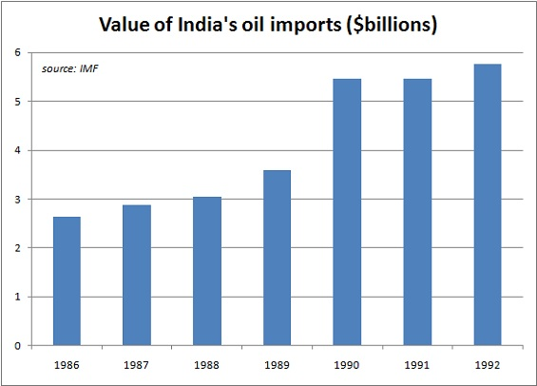
Figure 2. India’s trade balance, rolling 12-month average
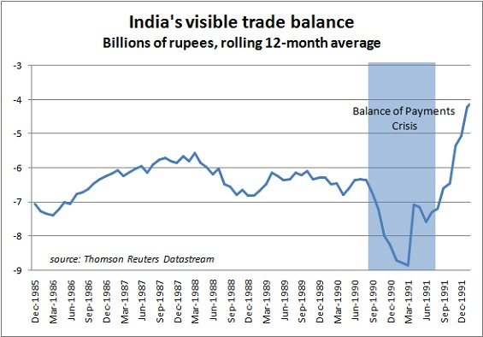
Figure 3. Growth of Foreign Currency Reserves after reforms
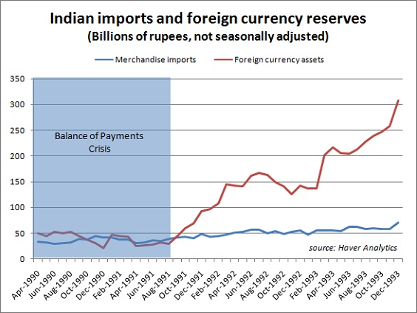
Figure 4. Decline in Total Indian Reserves excluding gold (1980 to 1993)
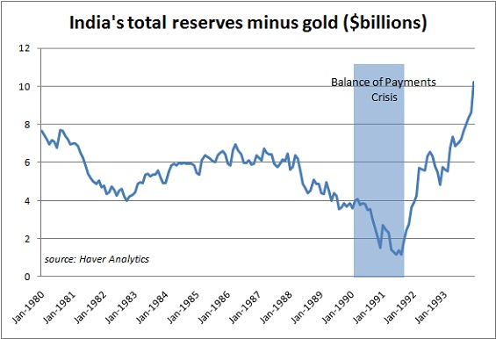

Figure 5. Depreciation of India rupee from 1980 to 1990. Two sharp falls mark the devaluation of rupee by the Indian government.
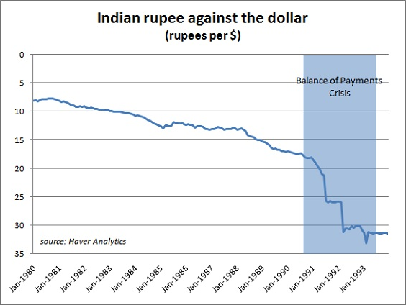
Figure 6. Number of months India’s reserves could cover cost of imports (1980 to 2012)
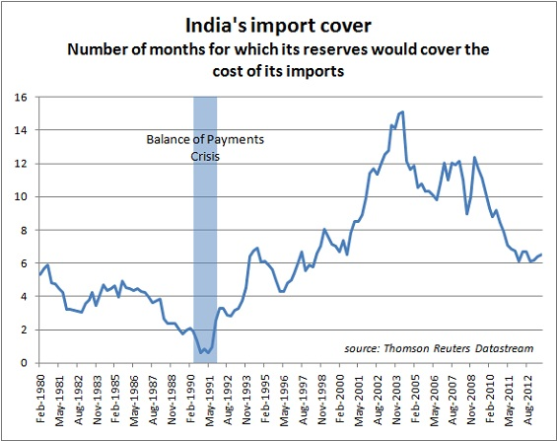

Figure 7. Size of Indian economy in 2013 compared to 1991
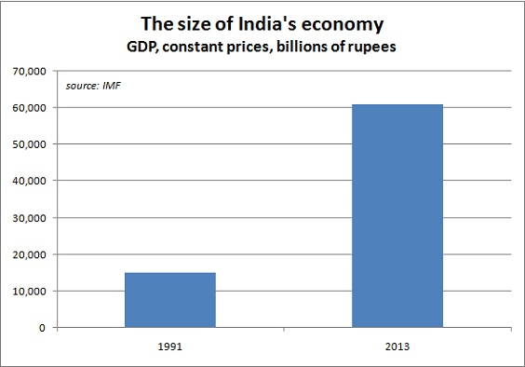
Figure 8. India’s share of world GDP (1980 to 2010)
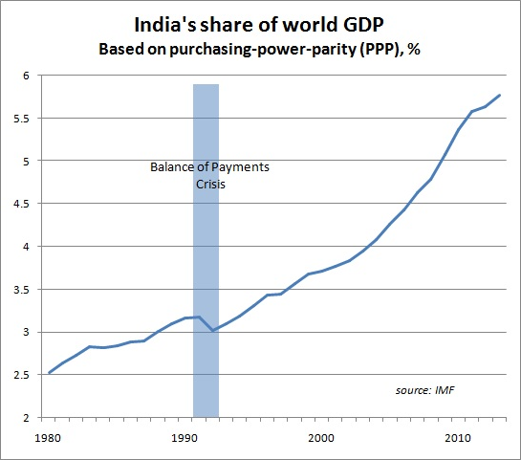
Figure 9. Effect of Reforms: Average Daily turnover in National Stock Exchange reaches (~USD 70 billion) in 2007 from almost negligible amounts.
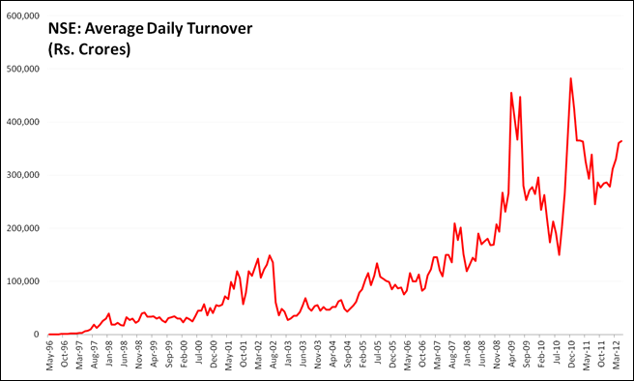
Figure 10. Effect of Reforms: Number of Trades on National Stock Exchange reaches an all-time high in 2008.
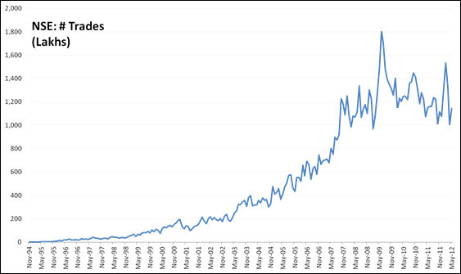
Figure 11. More than USD 300 billion of FDI inflow in India since 1999
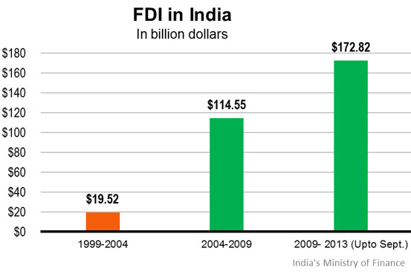
Figure 12. Growth in Indian economy since Independence
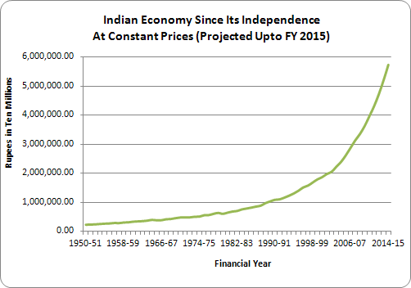
Figure 13. Economic growth exceeding 6 percent since 1991 reforms
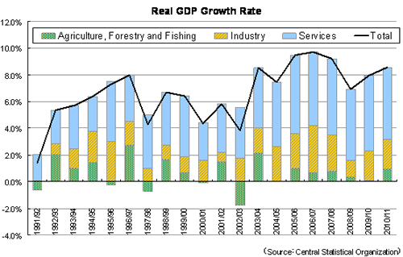
Figure 14. BSE Sensex increases more than threefold between 2004 and 2008.
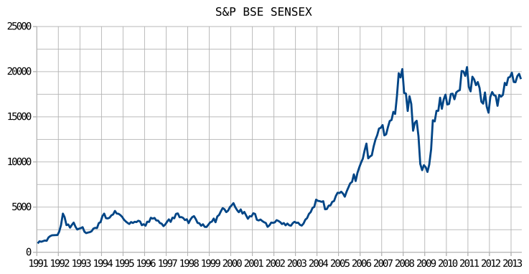

Figure 15: Stock performance of Shriram Transport Finance since 2003
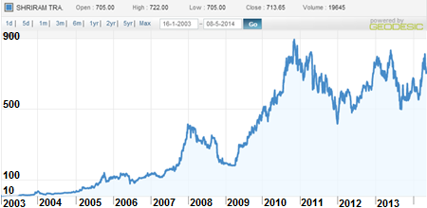
Figure 16: Stock performance of Yes Bank since IPO in 2005
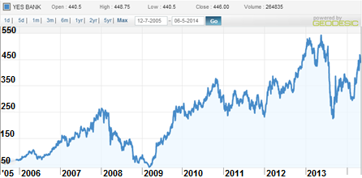

Figure 17: Stock performance of Kotak Mahindra Finance Limited since 2003
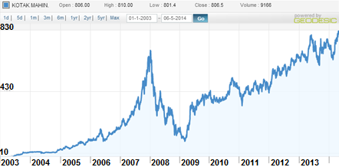
Figure 18: Stock performance of Indiabulls Financial Services from 2003 to 2008
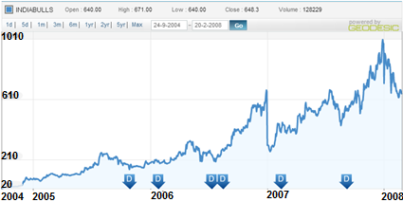

Figure 19. Reduction in Cash Reserve Ratio and Statutory Liquidity Ratio after reforms
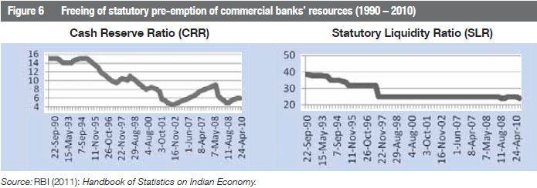
Figure 20. Market Capitalization of NSE and BSE between 1993 and 2010
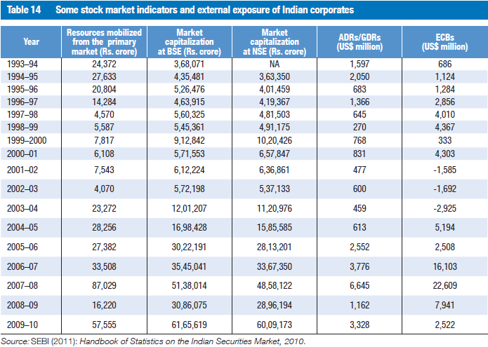

Figure 21: Increase in performance of Banks sector since reforms
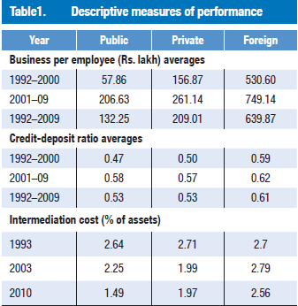
Figure 22: Decline in Non-Performing Assets of Banks since reforms
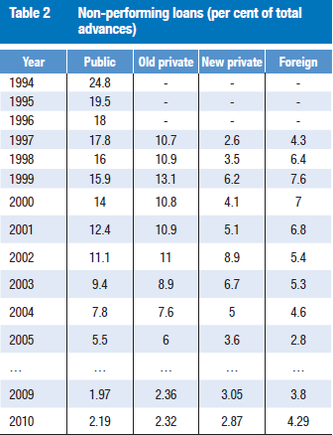
Figure 23. Total Value of IPOs in India since 1993
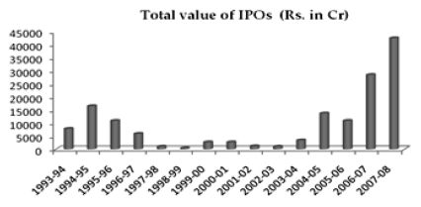

References
Banga, Rashmi, and Abhijit Das. "Twenty Years of India's Liberalization: Experiences and Lessons." Web. Apr. 2014
Prakash, B.A. The Indian Economy Since 1991: Economic Reforms and Performance. Pearson Education. Web.
Saha, Malayendu. "Indian Economy and Growth of Financial Market in the Contemporary Phase of the Globalization Era." 2012. Web. Apr. 2014.
"How India's Liberalization Shaped a Generation of Entrepreneurs - Knowledge@Wharton." KnowledgeWharton How Indias Liberalization Shaped a Generation of Entrepreneurs Comments. 15 Feb. 2012. Web. 13 May 2014.
"Indian Economy 2011: Economic Expansion Would Be Fragile But It Is Expected That Growth Would Be Inclusive & Sustainable." THE UNIDOW POST. Web. 13 May 2014.
"Press Releases." Signing of Japanese ODA Loan Agreements with the Government of India. 16 June 2011. Web. 13 May 2014.
Allen, Kate. "Back to the Future: Is India Heading towards Another Balance of Payments Crisis?" FT Data. 19 Aug. 2013. Web. 13 May 2014.
Kala, Anant V. "Indian Government Boasts About FDI Record - India Real Time - WSJ." India Real Time RSS. 30 Jan. 2014. Web. 13 May 2014.
"NSE - Falling Volumes." The Third I. June 2012. Web. 13 May 2014.
Majumdar, Shyamal, and Raghavendra Kamath. "The Man behind Indiabulls' Success." The Man behind Indiabulls' Success. 23 Apr. 2008. Web. May 2014.
Nayak, Mahesh. "The Rs 29,000-crore Surprise." - Business Today. 21 Oct. 2007. Web. May 2014.
Kamath, Raghavendra, and Niladri Bhattacharya. "Indiabulls: Life after '10,000 Hours'" Business Standard: News & Analysis on Economy, Business and Market. 21 Aug. 2011. Web. May 2014.
Sanghvi, Vir. "Uday Kotak." Vir Sanghvi. Web. May 2014.
Prasad, Shishir, and Pravin Palande. "Uday Kotak: Banking At High Velocity." Forbes India Magazine -. 10 Nov. 2011. Web. 13 May 2014.
KAVLEKAR, POORNIMA. "SmartCEO - Magazine - Cover Story - How Rana Kapoor Built Yes Bank." SmartCEO - Magazine - Cover Story - How Rana Kapoor Built Yes Bank. 1 Oct. 2012. Web. 13 May 2014.
"Can YES Bank, India's Youngest and Fastest-growing Bank, Be a Model for Newer Entrants? - Knowledge@Wharton." KnowledgeWharton Can YES Bank Indias Youngest and Fastestgrowing Bank Be a Model for Newer Entrants Comments. 1 Feb. 2012. Web. 13 May 2014.
Srinivas, Alam. "How to Be a 'Yes' Man." - Business Today. 5 Feb. 2009. Web. 13 May 2014.
"Our Journey - Shriram Transport Finance Company Ltd." Our Journey - Shriram Transport Finance Company Ltd. Web. 13 May 2014.
Prasad, Shishir. "The Success Story of Shriram Transport Finance." Forbes India Magazine -. 18 Apr. 2013. Web. 13 May 2014.
Madhavan, M. "R Sridhar on What Makes Shriram Transport Finance Company a Success." - Business Today. 17 Jan. 2012. Web. 13 May 2014.
"Shriram Transport Finance to Expand Car Lending Book." Yahoo India Finance. 4 Mar. 2014. Web. 13 May 2014.
Kumar, Pranav. "An Evolutionary Success Story." Sept. 2011. Web.

Banga, Rashmi, and Abhijit Das. "Twenty Years of India's Liberalization: Experiences and Lessons." Web. Apr. 2014
Sylla, Richard. "Does Financial Sector Development Precede Economic Development." 30 June 2005.
Rajagopal, Arvind. POLITICS AFTER TELEVISION: RELIGIOUS NATIONALISM AND THE RESHAPING OF THE INDIAN PUBLIC. Web. Apr. 2014.
Rajagopal, Arvind. POLITICS AFTER TELEVISION: RELIGIOUS NATIONALISM AND THE RESHAPING OF THE INDIAN PUBLIC. Web. Apr. 2014.
Rajagopal, Arvind. POLITICS AFTER TELEVISION: RELIGIOUS NATIONALISM AND THE RESHAPING OF THE INDIAN PUBLIC. Web. Apr. 2014.
Cerra, Valerie, and Shweta Saxena. "What Caused the 1991 Currency Crisis in India." Web. Apr. 2014.
Rajagopal, Arvind. POLITICS AFTER TELEVISION: RELIGIOUS NATIONALISM AND THE RESHAPING OF THE INDIAN PUBLIC. Web. Apr. 2014.
Rajagopal, Arvind. POLITICS AFTER TELEVISION: RELIGIOUS NATIONALISM AND THE RESHAPING OF THE INDIAN PUBLIC. Web. Apr. 2014
Banga, Rashmi, and Abhijit Das. "Twenty Years of India's Liberalization: Experiences and Lessons." Web. Apr. 2014
Saha, Malayendu. "Indian Economy and Growth of Financial Market in the Contemporary Phase of the Globalization Era." 2012. Web. Apr. 2014.
Saha, Malayendu. "Indian Economy and Growth of Financial Market in the Contemporary Phase of the Globalization Era." 2012. Web. Apr. 2014.
Saha, Malayendu. "Indian Economy and Growth of Financial Market in the Contemporary Phase of the Globalization Era." 2012. Web. Apr. 2014.
Saha, Malayendu. "Indian Economy and Growth of Financial Market in the Contemporary Phase of the Globalization Era." 2012. Web. Apr. 2014.
Saha, Malayendu. "Indian Economy and Growth of Financial Market in the Contemporary Phase of the Globalization Era." 2012. Web. Apr. 2014.
Saha, Malayendu. "Indian Economy and Growth of Financial Market in the Contemporary Phase of the Globalization Era." 2012. Web. Apr. 2014.
Based on personal interview with Uday Kotak held on Jaunary 17th, 2014 in Mumbai, India.

